CHAPTER III
METHODOLOGIES
A. Existing Algorithm
I. Algorithm
This study is focused on Intelligent Personal Assistant Development Platform. Before discussing the actual algorithms to be used in the development phase, this section will briefly discuss a typical IPA Algorithm and how it works. This concept is important to fully understand the relevance of the to-be-discussed core algorithms and how will it all be combined to build a development platform.
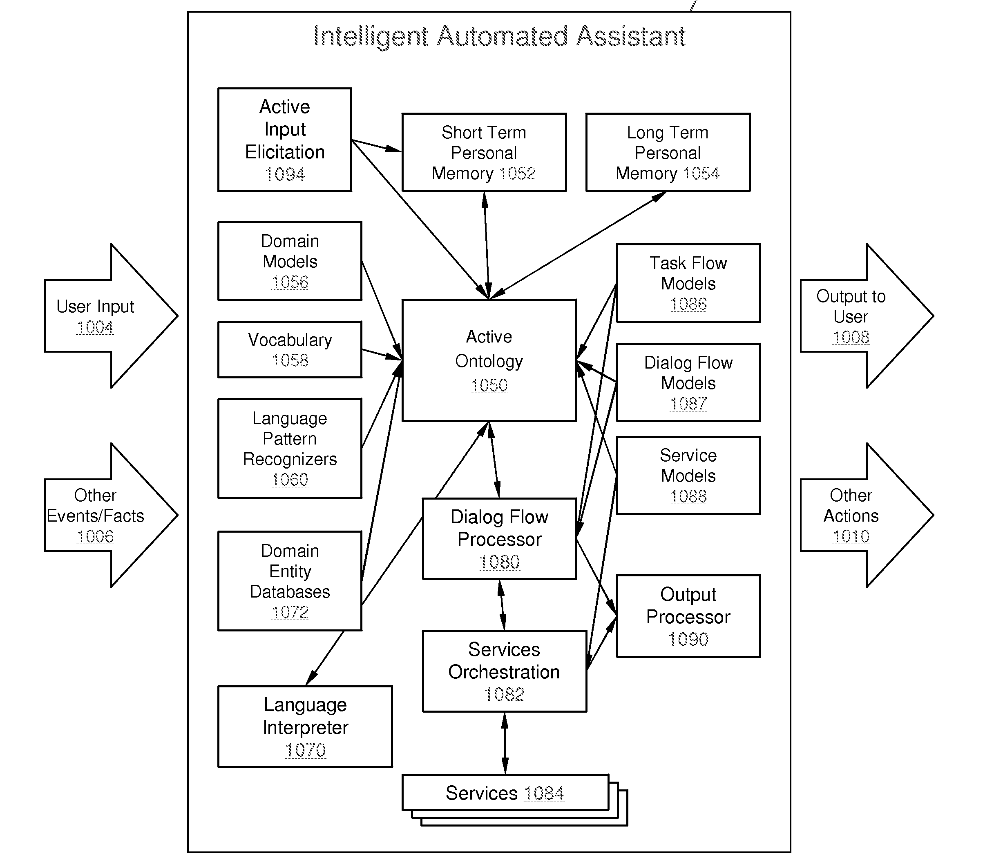
An IPA Algorithm:
On the above diagram we can see how many components work separately inside an IPA Core. Language Processing, Vocabularies, Dialog Management etc. act as separate modules and the tedious tasks of incorporating and making them work altogether is the burden of the developer.
II. Problems

B. Proposed Algorithm
After thorough analyzation, we conceptualized an algorithm that will simplify the above stated process. This is done by grouping the three main components (Speech Recognition, Language Understanding, Speech Synthesis) and combining them to develop a core which will act as the central processing module and message bus. External and Add-On modules and services will be then incorporated by accessing the Platform's API.

I. Algorithm
II. Enhancements
C. Simulation
I. Manual
II. Computerized

